本方案的3D 设计基于 ESP 32 C3 的集成主板设计，建议优先考虑以下购买的推荐
其他方案ESP32 S3 需要DIY 把线路电池充放电模块焊接好，动手能力弱的不建议采用该方案。
（This solution is 3D-designed based on the integrated ESP32-C3 mainboard. The following purchasing options are highly recommended.
For solutions using ESP32-S3, you need to manually solder circuits, batteries and charge-discharge modules by yourself. This version is not recommended for users with limited hands-on skills.）

- 主板购买：
淘宝门店：Surfer 冲浪者小智AI
V3组合套件（含屏幕，电池，喇叭）

Mainboard Purchase
Taobao Store: Surfer Smart AI
V3 Combo Kit (Including display screen, battery and speaker)

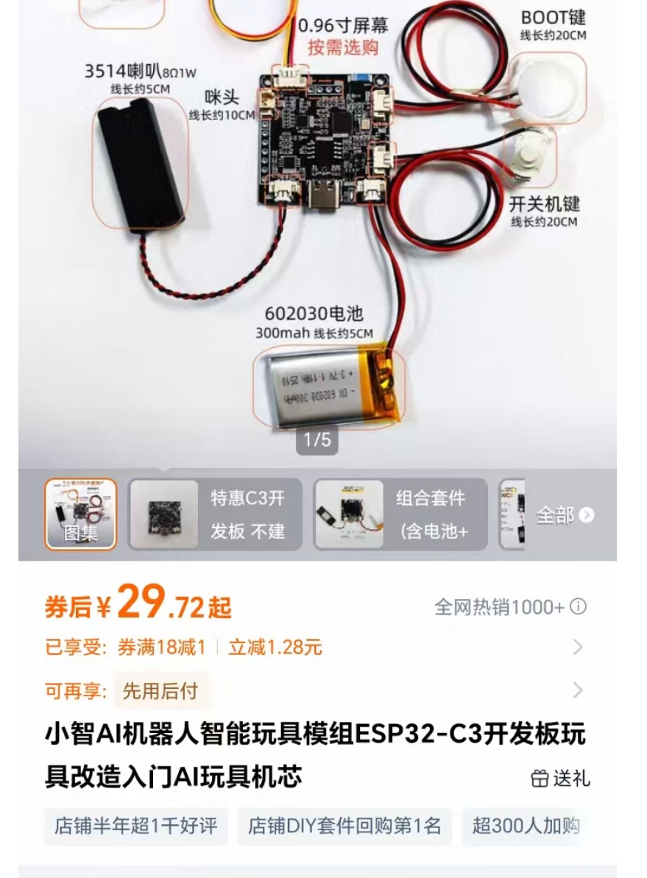

- 耳朵两个开关按钮
淘宝门店：CDOE
无锁复位跟自锁模式，各买一个，一个作为主板的电源开关（自锁开关），一个作为BOOT 复位按键触发按键（无锁复位开关）

Two ear switch buttons
Taobao Store: CDOE
Buy one momentary reset switch and one latching switch respectively.
Use the latching switch as the mainboard power switch, and the momentary reset switch as the BOOT trigger key.
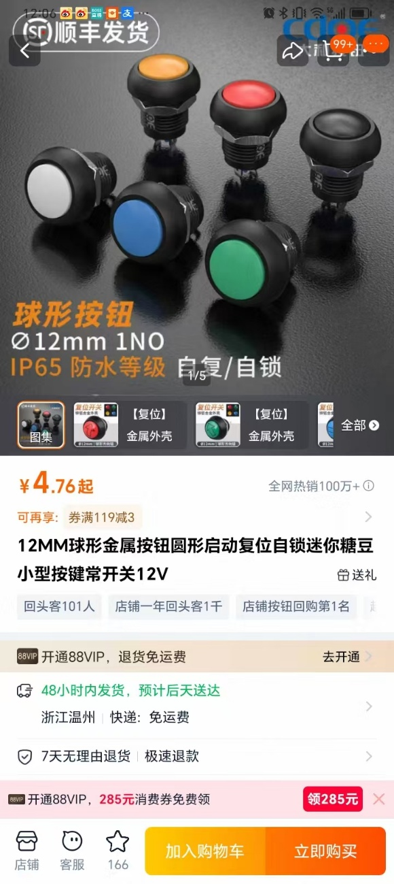
- Type C 公母转换延长线
备注: 公对母，双直头的

Type-C Male to Female Extension Cable
Note: Straight male-to-female dual-head type
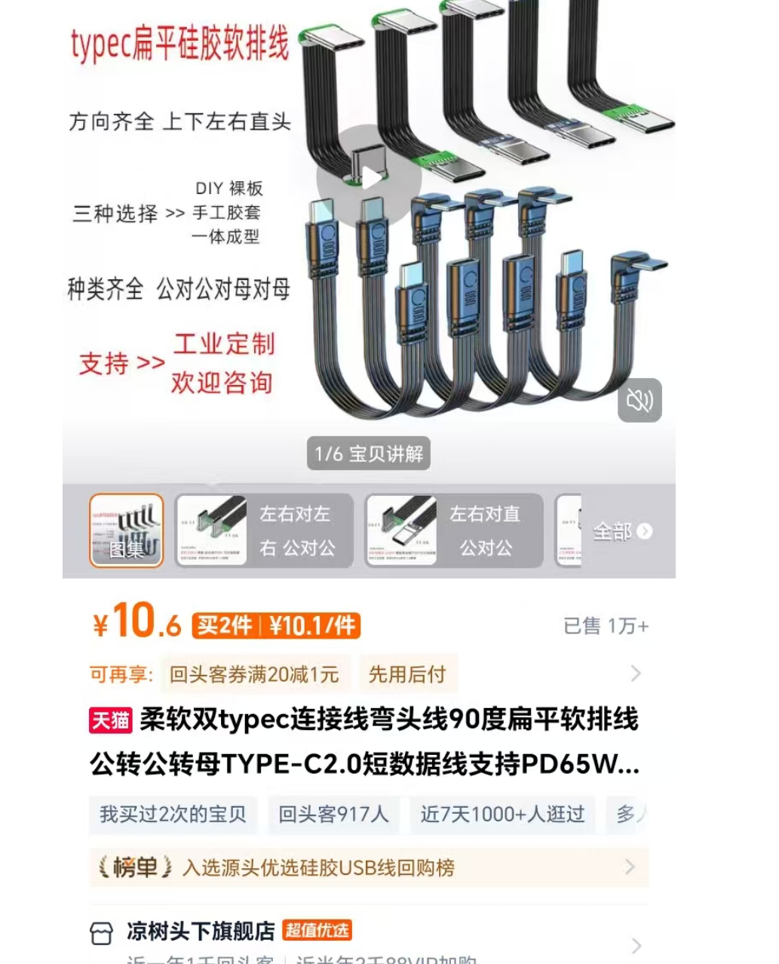

- DIY 贴纸采用UV 打印LOGO 贴，请自行淘宝购买自己的方案，这里不做推荐
DIY stickers adopt UV printed logo decals. Please purchase suitable styles on Taobao by yourself, no specific recommendations here.

5、0.96英寸的OLED 屏幕
淘宝商店：深圳思诚达 电子元器件
备注： 其他商家均可，0.96为通用，动手能力差的话购买已经焊接好引针的屏幕

0.96-inch OLED Display Screen
Taobao Shop: Shenzhen Sichengda Electronic Components
Note: Products from other merchants are also acceptable. 0.96 inch is a universal specification. It is recommended to buy pre-soldered pin headers if you have poor hands-on ability.

